Registration Form: CGS Formation Course Level 1, Parts I & II  Mail to: Mt. Sacred Heart School  (Attn. Michele Carr)  619 Mt. Sacred Heart Rd.  San Antonio, TX 78216  Send registration form with your $50.00 non-refundable deposit by June 10th. Remaining balance due by course date.  Name: _________________________  Tel: (____)_________________  Email: _________________________  Address: _______________________  City/State/Zip:_______________  ___________________________  Parish:______________________  Denomination:________________ |  |  | About Catechesis of  The Good Shepherd  The Catechesis of the Good Shepherd is a Montessori-based religious formation program for children, beginning at the age of three. It seeks to create and facilitate a  sacred, “hands-on” space for children, called an atrium, in which both the children and the catechists can hear, ponder, and celebrate the most essential mysteries of the Christian  faith as revealed in the scriptures and the liturgy.  Originally developed over 60 years ago in Rome by Dr. Sofia Cavalletti and Gianna Gobbi, the Catechesis continues to spread world wide and is used with adaptation in various Christian traditions.  This Level I course grounds the participant in the theory and praxis of the Catechesis of the Good Shepherd while also concretely preparing her/him to develop and facilitate an atrium for 3-6 year olds.  Certification  At the completion of the course (90 hours) the participants will receive a Level I certificate issued by the National Association of the Catechesis of the Good Shepherd. A fee for the certificate will be included in the course cost. In order to receive the certificate, participants are expected to attend all course sessions, complete reading assignments, and atrium observations. |  | Catechesis of The Good Shepherd  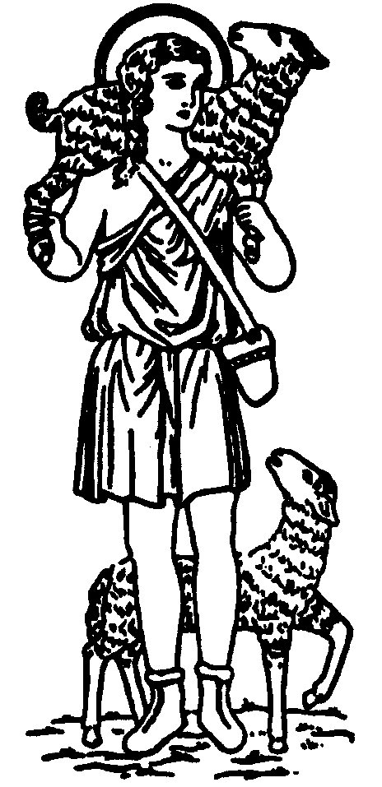  FORMATION COURSE  Level 1 (3-6), Parts I & II  A formation experience for catechists working with children ages 3-6  Part I: Summer 2022  June 9-11, 2022  July 7-10, 2022  Part II: Fall 2022  Weekends TBD  Location:  Mount Sacred Heart Catholic School  619 Mt. Sacred Heart Rd, SA TX 78216  mcarr@mountsacredheart.com

Course Objectives  - To explore with participants the general developmental and religious characteristics of the 3-6 year old child.  - To facilitate meditation on the biblical and liturgical themes of Catechesis of the Good Shepherd.  - To offer guidelines and assistance in setting up an atrium for the 3-6 year old child.  - To deepen the participants’ ability to observe and learn from children, while also exploring avenues for deepening the parental and congregational ability to observe and learn from children.  This formation requires a deep commitment on the part of the catechist; it is life giving and can be life changing.  Tuition  This course is being offered in two parts of six days each, for a total of 12 days. Tuition for course is $350 per part (includes a $50 non-refundable deposit). |  |  | About our Formation Leader  Beate Buescher has been in the process of being transformed by the Catechesis of the Good Shepherd since 2003, when she began assisting in a Level 1 atrium. This started a beautiful journey for her and her children, and led her to help establish a Level 1 atrium in a neighboring parish 3 years later. As her role transitioned to Good Shepherd Coordinator, she completed the next two levels of formation and helped to begin the Level 2 and Level 3 atria. Currently she is co-wondering with Level 1 and Level 3 children at St. Joseph – Honey Creek.  Beate has been married for almost 3 decades to a wonderful man who patiently cooks dinner on the nights she loses herself in the atrium. Beate’s educational background is in early childhood education and biology, perfect backbones for wondering about the miracles of God’s world with the children. In her spare time, she enjoys leading scripture study, reading, knitting and spending time outdoors. |  | Required Texts :  Cavalletti, Sofia. Religious Potential of the Child I (vol. 1), Chicago: Liturgy Training Publications, 1992 (RPC I)  Gobbi, Gianna. Listening to God with Children: Montessori Principles Applied to the Catechesis of Children, Loveland, OH: Treehaus Publications, 2002. (LTGWC)  Coulter, Patricia. The Good Shepherd and the Child: A Joyful Journey, Chicago Training Publications, 2014. (JJ)  Recommended Texts :  Cavalletti, Sofia. The History of the Kingdom of God: Liturgy and the Building of the Kingdom, Chicago: Liturgy Training Publications, 2013. (LBK)  Lillig, Tina. Catechesis of the Good Shepherd in a Parish Setting, Chicago: Liturgy Training Publications, 1998. (Lillig)  All can be ordered at cgsusa.org

